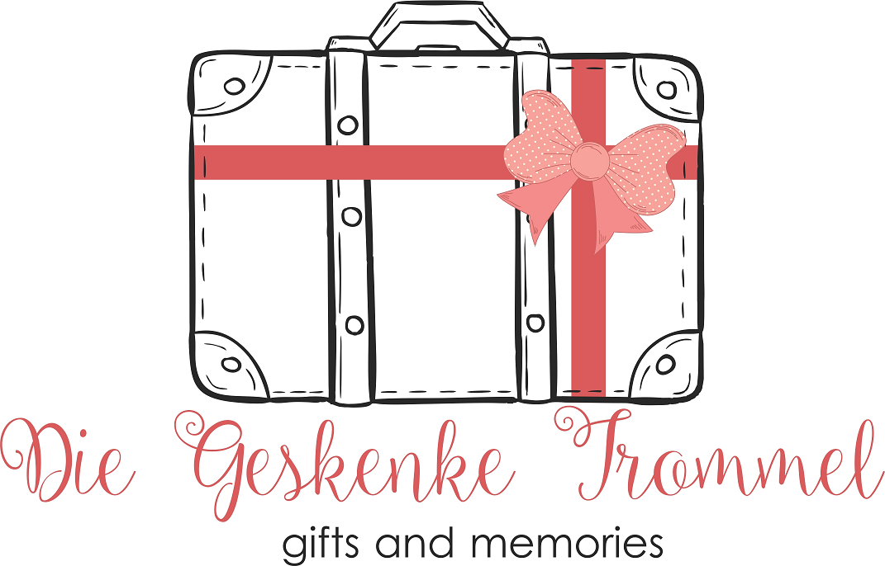
Ria Nel 082 804 1304
E mail: rianelmus@absamail.co.za Facebook: www.diegeskenketrommel.co.za

APPLICATION FOR
CONTRACTUAL AGREEMENT BETWEEN
DIE GESKENKE TROMMEL
AND
EXHIBITORS NAME AND SURNAME: _____________________________
ID NUMBER: _____________________________
CONTACT NUMBER: _____________________________
EMAIL ADDRESS: _____________________________
AREA WHERE I AM STAYING: _____________________________

- PARTICIPATION:
VENUE | CARACTER | AREA |  |  | COMMISSION | TIME SCHEDULE
CULLIFEST | FESTIVAL | CULLINAN |  |  | 25% | APR
GLENFAIR | POP UP SHOP | PRETORIA |  |  | 25% | DAILY
PROTEAFEES | FESTIVAL | RAYTON |  |  | 25% | APR
RANDFONTEIN SHOW | NATIONAL SHOW | RANDFONTEIN |  |  | 25% | MAR
WAVERLEY PLAZA | POP UP SHOP | PRETORIA |  |  | 25% | DAILY
WONDERBOOM JUNCTION | POP UP SHOP | PRETORIA |  |  | 25% | DAILY
DATES AND VENUES MAY VARY DUE TO UNFORSEEN CIRCUMSTANCES
NEW VENUES WILL BE LISTED ONCE CONFIRMED

- PRODUCTS:

2.1 IN GENERAL
1. Photos of items must be forwarded for approval.
2. Once approved, items MUST BE MARKED by you with barcodes provided by DIE GESKENKE TROMMEL.
3. Quality and Barcode Control has to be done by a Staff Member before unpacking will be allowed @ ANY SHOP.
4. IF ITEMS ARE NOT MARKED/WRONGLY MARKED, IT WILL BE TAKEN OFF THE TABLES, ALLOCATED AND SOLD ON BEHALF OF KUNGWINI PTY (LTD), PRETORIA.
5. NO NAME, NO TELEPHONE NUMBER, NO ADDRESS OR ADVERTISEMENT may be shown on ANY of your articles.
6. Please contact Ria in advance to arrange if your Courier Services will deliver.
7. DIE GESKENKE TROMMEL is a GIFT SHOP and NOT A FLEA MARKET. This means that corresponding items will be packed with or next to or close to stock with the same characteristics or themes.

- SUMMARY OF DUTIES AND RESPONSIBILITIES OF EXHIBITORS:

- To sufficiently supply “ Die Geskenke Trommel “ with quality goods / items for sale to the general public at fairs, markets and in Pop Up Shops.
- To make available additional stock to “ Die Geskenke Trommel “ when requested for the purposes of the Markets/ POP UP SHOPS you participating in.
- To ensure that all goods/ items are labelled with barcodes provided by “ Die Geskenke Trommel “.
- To ensure that the goods / items are packaged in sturdy and stable containers, with lids that close with clips, especially for the markets for which “ Die Geskenke Trommel “ provides transportation. No boxes will be allowed. Not applicable for Pop Up Shops.
- Note that no exhibitor will be allowed to manage/man his/her exhibit.
- Be sure that all exhibits / products comply with legal standards and requirements eg SABS
- Assistance in marketing each market by word of mouth, forwarding adverts by mails, sms’e, Face Book and other social media.

Please sign each of the pages at the bottom before forwarding to the Organisers.

Exhibitor Signature Date

Die Geskenke Trommel Signature Date

